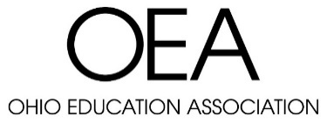

OEA WELLNESS GRANT APPLICATION
2022-2023

Name of Person Making Request Name of Local
Click here to enter text. Click here to enter text.

Region 1☐ 2☐ 3☐ 4☐

Your Position in Local Email Address
Click here to enter text. Click here to enter text.

Phone Number Name of Labor Relations Consultant
Click here to enter text. Click here to enter text.

Current Membership Count Activity Planned
Click here to enter text. Click here to enter text.

Target Date(s) of Activities Amount of Funding Requested
Click here to enter text. Click here to enter text.

AVAILABLE BEGINNING SEPTEMBER 5, 2022
- Up to $5 per active member
- Activity must be completed by May 31, 2023
- Receipts must be submitted for reimbursement by June 15, 2023
*Funds cannot be used to purchase gift cards

By signing this form, you acknowledge and agree to use any OEA funding solely and expressly for the purpose of covering the specific costs of the activities planned.

____________________________________________________________________________
Signature of Person Responsible for the Activity Date

____________________________________________________________________________
Regional Director Signature Date

