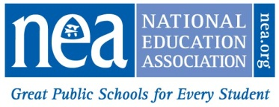
NATIONAL EDUCATION ASSOCIATION
2018-19 Student Rebate Application

Complete form and mail or email on or before MAY 1, 2019 to:

Mail: Or Email:
NEA Business &Financial Services
Attn: Student Rebate
1201 16th Street, NW, Ste. 419 studentrebate@nea.org
Washington, DC 20036-3290

PLEASE CLEARLY PRINT or TYPE
NEA INDIVIDUAL ID
Or SSN 4
First NAME: |  | last name:
Telephone nUMBER: |  | former last name:
Address:
CITY: |  |  | STATE: |  |  | ZIP:
PERSONAL EMAIL ADDRESS:

Rebate of $20 for each year you held a Student membership up to four years will be issued provided the following requirements are met:

- 2018-19 must be your first year of educational employment and you must currently hold NEA Active membership. Substitute members are not eligible for the rebate.
- Previously You were an NEA student member. Please do not submit an application if you have never held an NEA student membership.
- Verification of your membership and eligibility will be made by NEA and a rebate check will be mailed to the address on the application in August 2019. If your address changes before August 2019 please send the updated address to studentrebate@nea.org
- NEA will not contact you prior to mailing your rebate check unless additional information is required. DO NOT SUBMIT MULTIPLE APPLICATIONS. This could delay processing!
Below is a record of my college or NEA chapter/state affiliate while I was an NEA Student member:
Year(s) NEA STUDENT MEMBERSHIP Was Held, e.g., 2017-2018 | NEA CHAPTER & STATE or COLLEGE WHEN  STUDENT MEMBERSHIP WAS HELD

SIGNATURE: DATE:

For NEA Use Only

